Tracey J Lyons
Bring Love and Faith Home
Amazon #1 bestselling Christian Historical romance author.
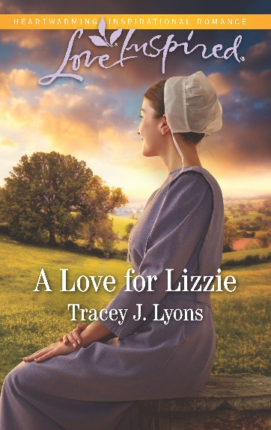 Harlequin Love Inspired July 2019
“Readers will be rooting for Lizzie in Tracey Lyons’ newest offering, A Love for Lizzie! Tracey has a terrific way of creating multidimensional characters who are both likable and compelling. I’m already looking forward to Tracey Lyons’ next book!” ~NYT and USA Today bestselling author Shelley Shepard Gray

